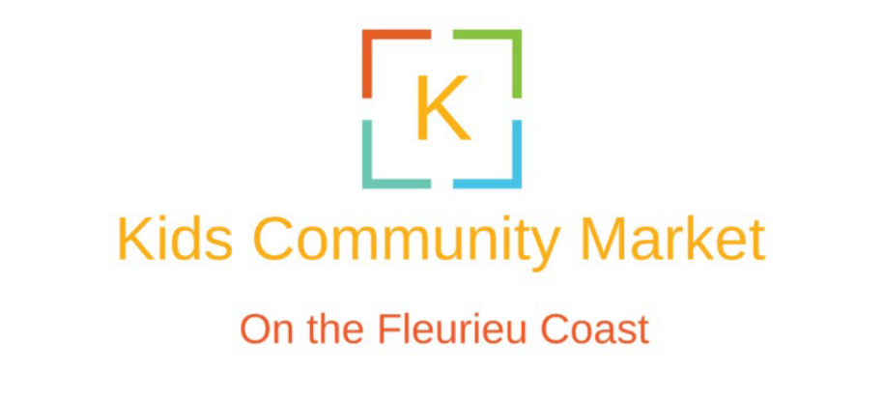
Term 4 Market – Normanville Village Green
FRIDAY 18TH DECEMBER 2026. From 4PM-7PM (set up from 3PM)
Contact Mel 0407 315 030
https://kidscommunitymarket.com/
CHILD’S NAME | CHILD’S AGE | PARENT/CAREGIVER | PARENT/CAREGIVER  CONTACT NUMBER
Please return form by 10th December 2026

Do you have a name for you stall?............................................
Do you need power?.................................................................
TELL US ABOUT YOUR IDEA….
_________________________________________________________________________________________________________________________________________________________________________________________________________________________________________________________________________________________________________________________________________________________________________________________________

